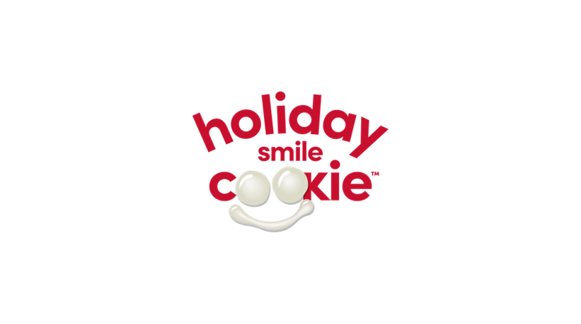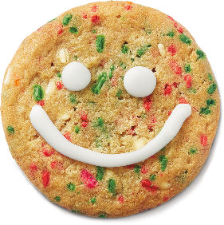
Pre-Order Form
From November 18 - 24, Tim Hortons Restaurant Owners will be supporting local charities, community groups and Tims Camps across Canada. Guests who purchase a freshly baked Holiday Smile Cookie will be donating to these great causes with 100% of proceeds being donated! To pre-order Tim Hortons Holiday Smile Cookies, complete this form and submit it to your nearest participating Tim Hortons Restaurant no less than 48 hours of your specified pick-up date & time. Or visit the Tim Hortons app, Uber Eats or Skip the Dishes to see if your Holiday Smile Cookies can be delivered.

Number of Cookies: |  | 12 Cookies per box

Your Name:
Address:
 | Telephone: | ( )
 | Email:

Pick Up Date: |  | Pick Up Time:

